Online Portfolio Projects

# Gazetteer

Given a brief to develop a gazetteer, a map that displays information on countries and points of interest, I was able to design and develop a great user experience for exploring multiple countries from around the world. The design aimed to present information to the user with as little interactions as possible, by incorporating API’s such as geolocation and developing preloaders. The real learning curve for myself was juggling multiple API’s from sources such as *RapidAPI,* and trudging through multiple documentations that relate to something found in a Gazetteer. After collecting all relevant data, it was important to handle all possible errors and display the correct information.

Below is an example of what a user will first see when reaching the website, a simple preloader that when also displays how the website works.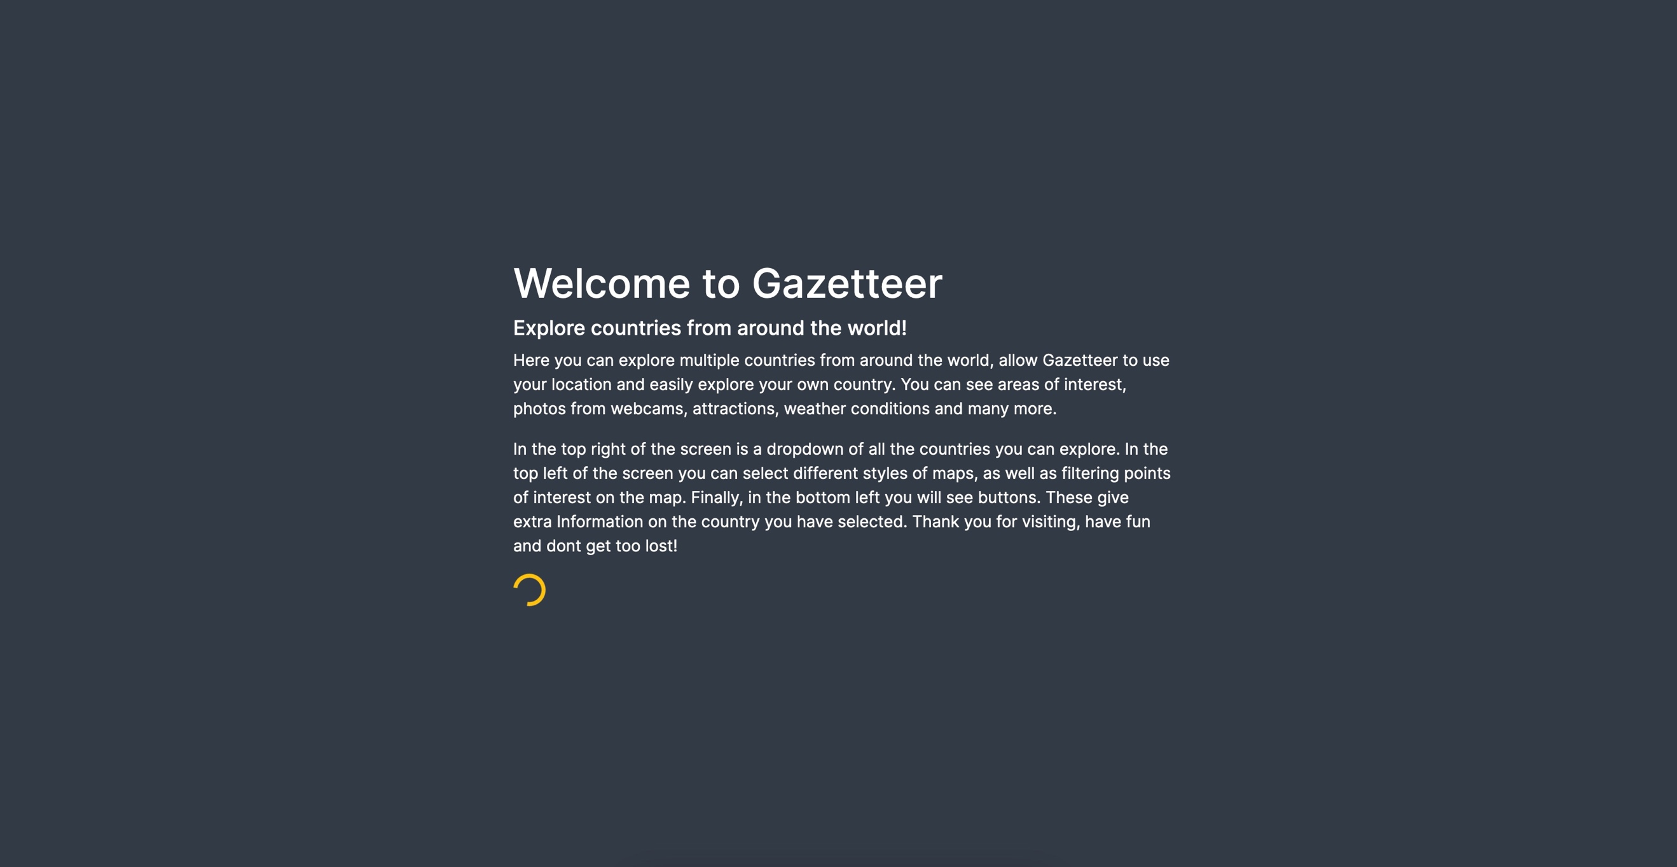

When first developed, many users were struggling with the overall functionality of the website. Working within an agile environment the design was adapted multiple times that created a better user experience. As you can see, the first image (design one) appears less rounded with more clutter whereas, the second image (design two) is clearer and shows more of the map.

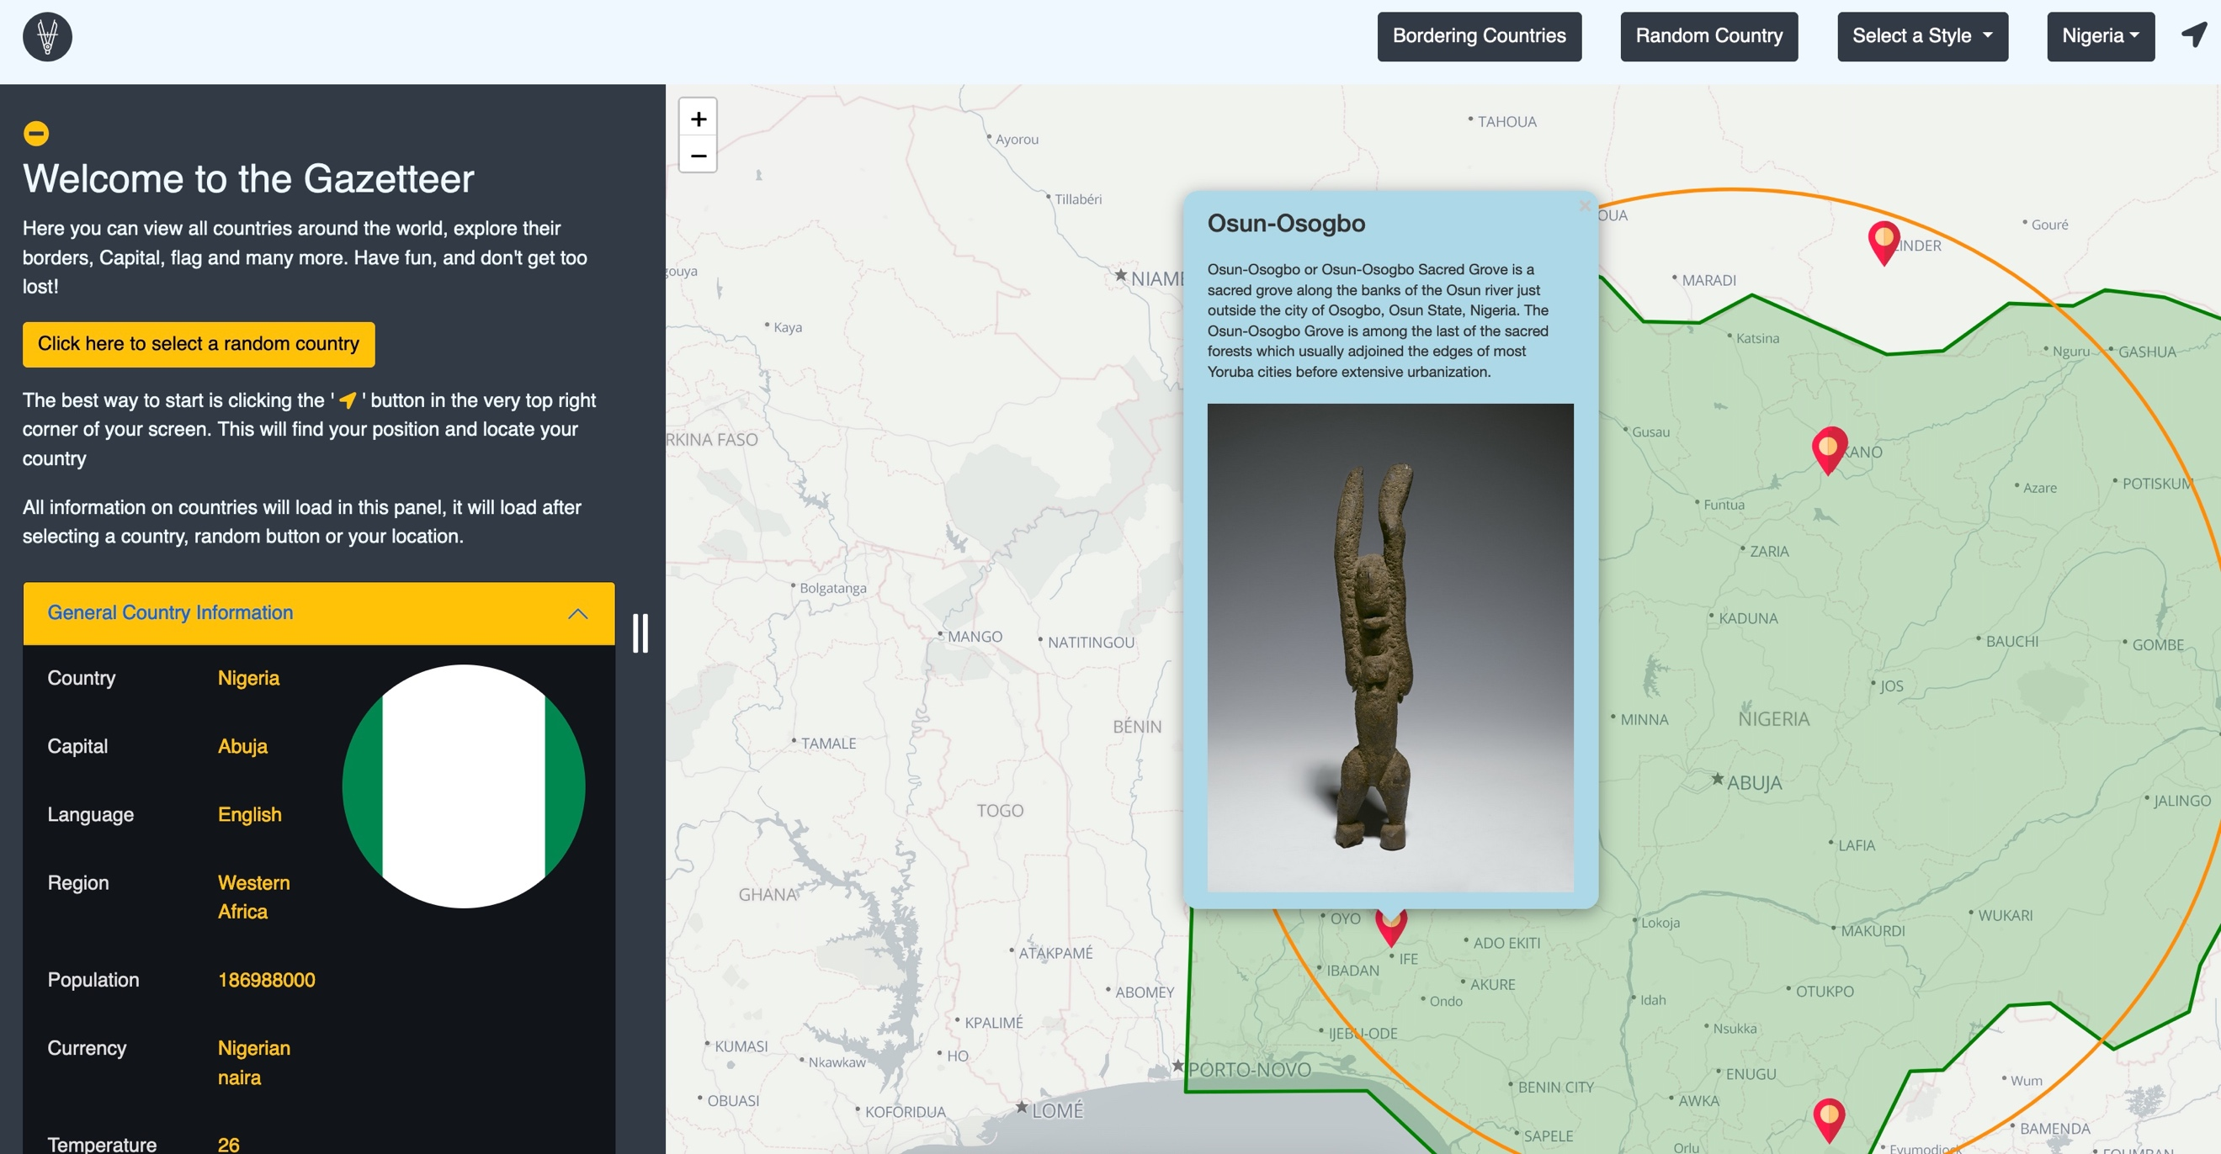

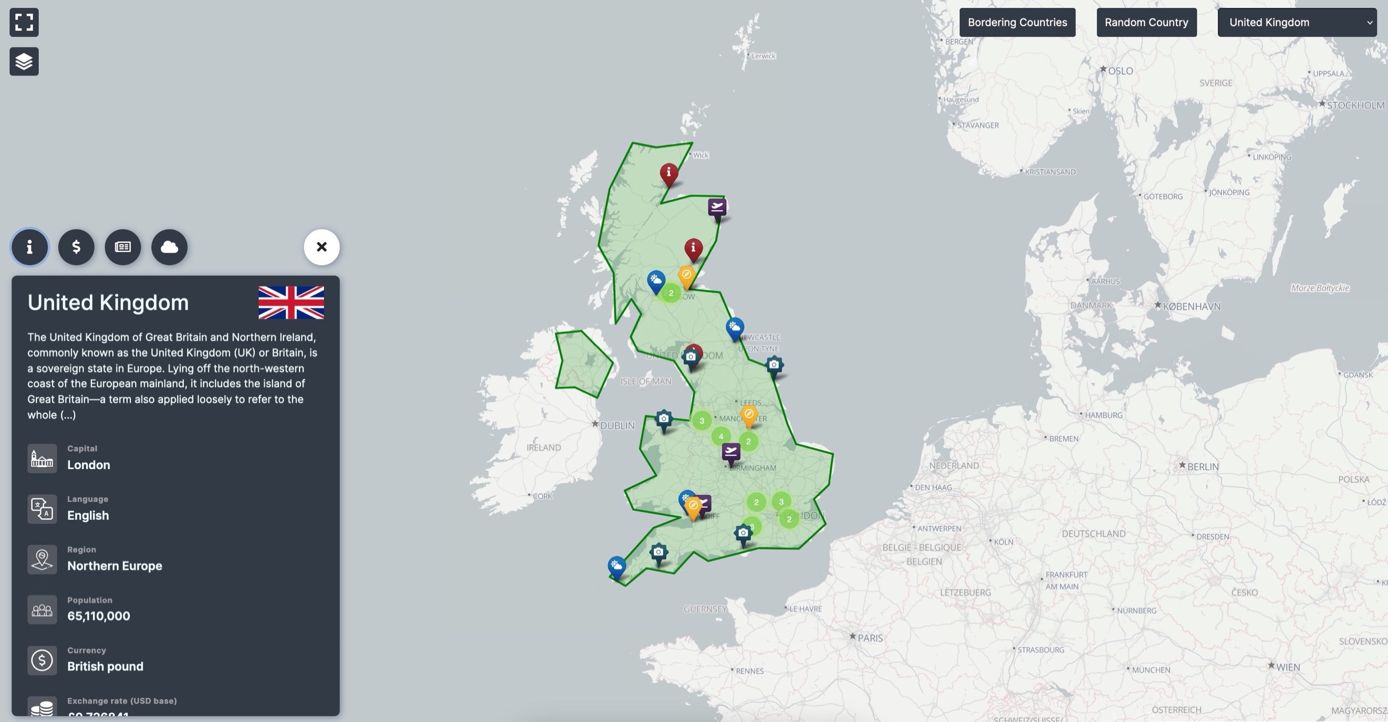

Thank you for having a read, please feel free to visit the website and explore the world!

# Ecommerce website

This ecommerce website uses both React and Redux to create a simple app. The biggest challenge came when incorporating a login system using Passport.js, whilst using Node and Express. The website included a full CRUD system, both for the products but also the users themselves.

# Reddit website

The aim for the project was to use React to make a simple but affective reddit copy. Throughout the design process it became apparent that a focus on responsiveness and transferring state around the app was integral to improving the user experience, compared to the official Reddit website. Below is an example of the responsiveness.

The app leans heavily on the use of states in React. For example, when a user searches the app, the text is quickly transferred around the app. This was where the challenged lied, balancing states and Lifecyle events without slowing the user down.

As you can see, the design is very minimal, delivering only what the user really wants to see.

# Company Directory

The Company Directory aims to collect data from a SQL database and manipulate It using methods such as ‘insert’ and ‘delete’. With data security in mind, user inputs must abide by the client and server-side validations. The backend incorporates OOP (Object Oriented Programming) through PHP, this allowed for encapsulation but also better readability within the codebase.

Below is an example of the validation process, this video shows an email already existing within the database, therefore the user cannot use that email.

<VIDEO>

Traversing and exploring data was critical to improving the user experience of the employees. For example, the search bar produces a dropdown which presents suggested personnel as well as the option to search by department. The bellow video explores this in action.

<VIDEO>